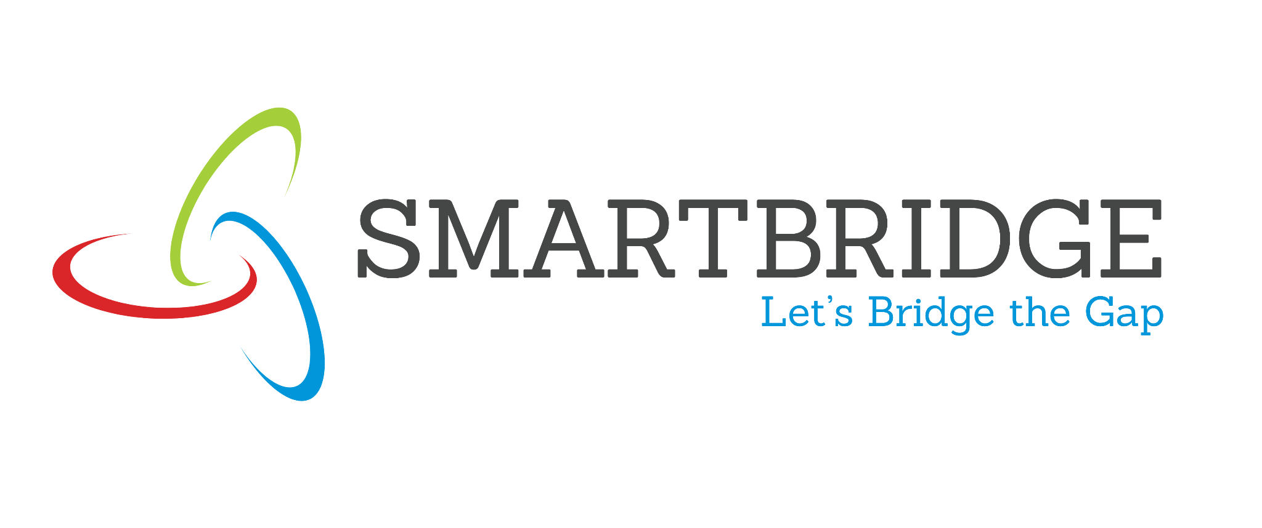 | 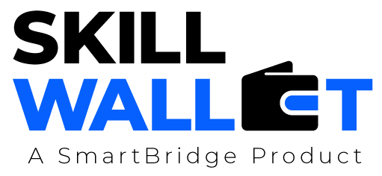

Empathy Map
Date | 08-07-2026
Team ID
Project Name | Smart Agricultural Production Optimization Engine (OptiCrop)
Maximum Marks | 4 Marks

Empathy Map
Create an empathy map to understand your customer/user from four perspectives - what they Say, Think, Do, and Feel - in relation to the problem your project addresses. This helps the team build a customer-centric solution.
SAYS  - "I don't know which crop is best suited for my soil."  - "I want to know the right Nitrogen, Phosphorous and Potassium levels for my land."  - "I need guidance based on rainfall and temperature, not just guesswork." | FARMER  (End User / Primary Persona) | THINKS  - Wonders if technology can really improve crop yield.  - Worries about wasting money on the wrong crop or fertilizer.  - Hopes for a simple, reliable way to make farming decisions.
DOES  - Tests soil manually and relies on traditional or family farming knowledge.  - Occasionally consults local agricultural officers for advice.  - Applies fertilizers and chooses crops based on assumption, not data. |  | FEELS  - Anxious about the risk of crop failure.  - Hopeful that data-driven recommendations could increase yield.  - Frustrated by the lack of accessible, easy-to-use tools.

